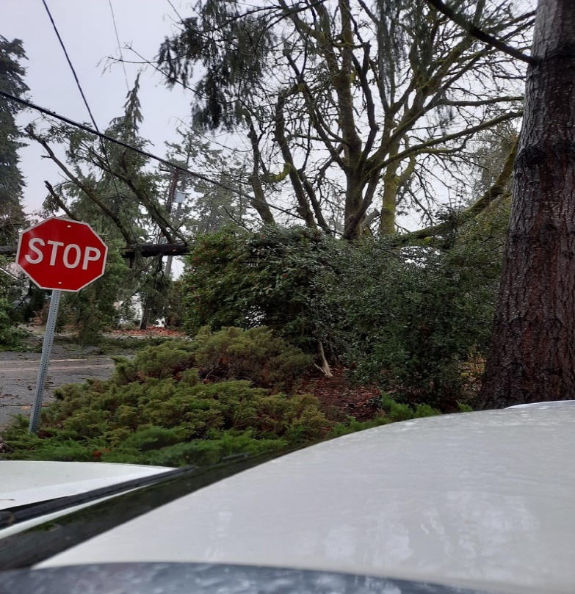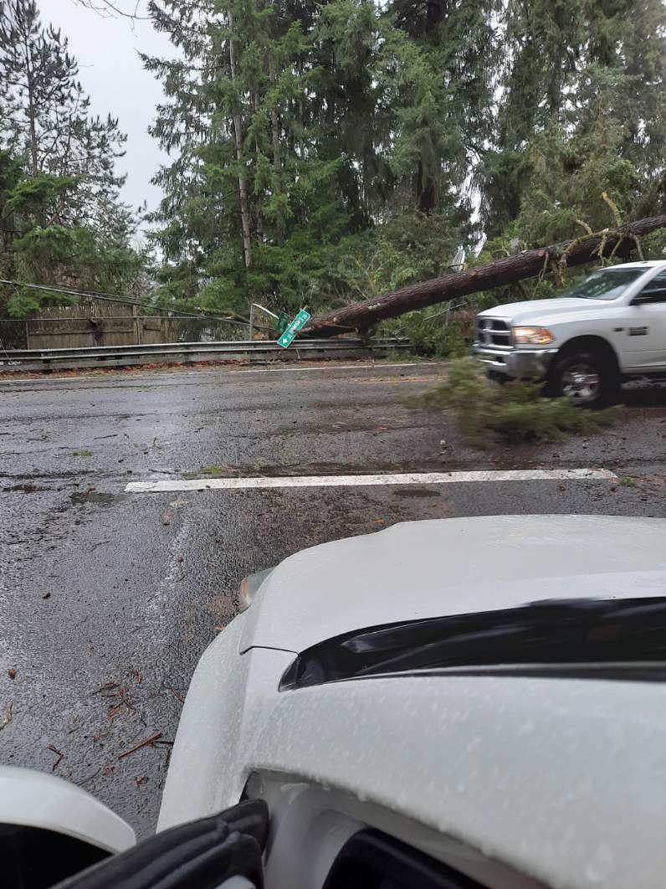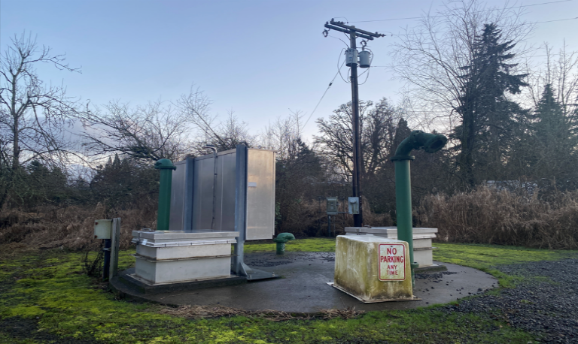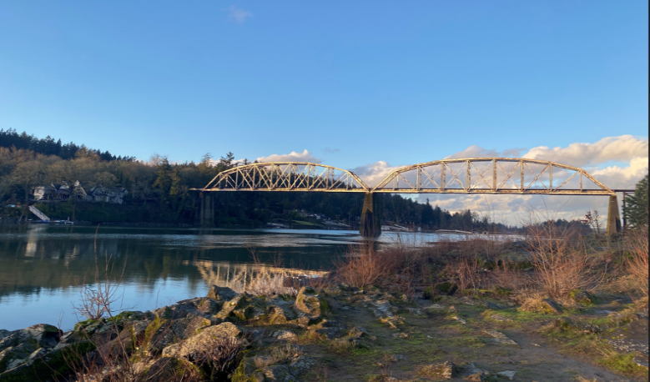

# Oak Lodge Water Services Addendum to the Clackamas County Multi-Jurisdictional Hazard Mitigation Plan

# City of _____ Addendum to the Clackamas County Multi-Jurisdictional Hazard Mitigation Plan

# City of _____ Addendum to the Clackamas County Multi-Jurisdictional Hazard Mitigation Plan

# City of _____ Addendum to the Clackamas County Multi-Jurisdictional Hazard Mitigation Plan

# City of _____ Addendum to the Clackamas County Multi-Jurisdictional Hazard Mitigation Plan

# City of _____ Addendum to the Clackamas County Multi-Jurisdictional Hazard Mitigation Plan

# City of _____ Addendum to the Clackamas County Multi-Jurisdictional Hazard Mitigation Plan

# City of _____ Addendum to the Clackamas County Multi-Jurisdictional Hazard Mitigation Plan

April 2024

Volume II: ­­Oak Lodge Water Services Addendum

This Natural Hazard Mitigation Plan was prepared by: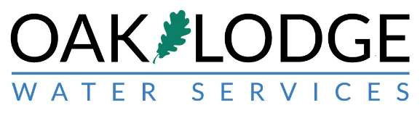

Funding provided by:

##### The Customers of Oak Lodge Water Services

With support from:



Planning grant funding provided by:



Federal Emergency Management Agency (FEMA)

Pre-Disaster Mitigation Program

Grant: EMS-2017-PC-0005

Sub-grant Application Reference: PDMC-PL-10-OR-2016-001, and

Additional Support Provided by:

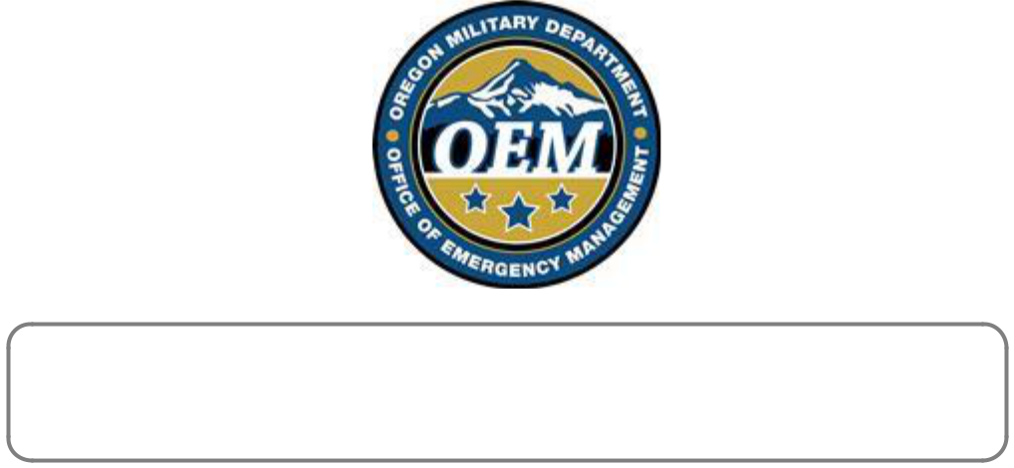

*This material is a result of tax-supported research and, as such, is not copyrightable.*

*It may be freely reprinted with the customary crediting of the source.*

# Table of Contents

#### Purpose, Mission, and Goals Page

#### NHMP Process, Participation, and Adoption Page

#### NHMP Implementation and Maintenance Page

#### Mitigation Strategy Page

#### Risk Assessment Page

#### Hazard Analysis Page

#### Community Characteristics Page

#### Community Assets Page

#### Hazard Characteristics Page

#### Drought Page

#### [Earthquake](#_Earthquake_(Cascadia_Subduction) Page

#### Flood Page

#### Landslide Page

#### Severe Weather (Extreme Heat, Windstorm, Winter Storm) Page

#### Volcanic Event Page

#### Wildfire Page

#### Attachment A: Action Items Page

#### Attachment B: Public Involvement Summary Page

# List of Tables and Figures

#### Tables Page

#### OLWS-1. Hazard Analysis Mix Page

#### OLWS-2. Asset Summary Page

#### [OLWS](#_Earthquake_(Cascadia_Subduction)-3. Natural Hazards Page

#### [OLWS](#_Earthquake_(Cascadia_Subduction)-4. Action Item Summary Page

#### 

#### Figures

#### OLWS-I. Oak Lodge Water Services – Governance and Management Page

#### [OLWS-II. USGS Understanding](#_Earthquake_(Cascadia_Subduction) Risk Page

#### [OLWS-III. Oak Lodge Water Services Service Area](#_Earthquake_(Cascadia_Subduction) Page

## Purpose

This document serves as the Oak Lodge Water Services (OLWS) addendum to the Clackamas County Multi-Jurisdiction Natural Hazards Mitigation Plan (NHMP). This addendum supplements information contained in Volume I (Clackamas County NHMP Basic Plan) and serves as the foundation for OLWS’s Hazard Mitigation Plan. Volume III (Appendices) provides additional information.

This addendum meets all the requirements of Title 44 CFR §201.6 including:

* Multi-jurisdictional Plan Requirements §201.6(a)(4),
* Multi-jurisdictional Planning Process §201.6(b)(1-3),
* Multi-Jurisdictional Risk Assessment §201.6(c)(2)(iii),
* Multi-jurisdictional Mitigation Strategy §201.6(c)(3)(iv),
* Multi-jurisdictional Plan Maintenance Process §201.6(c)(4), and
* Multi-jurisdictional Plan Adoption §201.6(c)(5).

This is the first addendum to the County NHMP for OLWS and builds on other OLWS planning efforts detailed further in this document.

A description of the jurisdiction specific planning and adoption process follows, along with community specific action items. Information about OLWS’s risk relative to the natural hazards relevant to the County is documented in the addendum’s Risk Assessment section. The section considers how OLWS’s risk differs from or matches that of the County’s. Additional information on Risk Assessment is provided within the Clackamas County NHMP’s Section 2 – Risk Assessment.

## Mitigation Plan Mission

The NHMP mission states the purpose and defines the primary functions of the NHMP. It is intended to be adaptable to any future changes made to the NHMP and need only to change if the community’s environment or priorities change.

OLWS concurs with the mission statement developed during the Clackamas County planning process (Volume I, Section 3):

*Promote sound public policy designed to protect citizens, critical facilities, infrastructure, private property, and the environment from natural hazards.*

This mission can be achieved by increasing public awareness, documenting the resources for risk reduction and loss-prevention, and identifying activities to guide the County, and OLWS, towards building a safer, more sustainable community.

## Mitigation Plan Goals

Mitigation plan goals are more specific statements of direction that Clackamas County and OLWS residents, as well as public and private partners can take while working to reduce OLWS’s risk from natural hazards. These statements of direction form a bridge between the broad mission statement, and serve as checkpoints, as agencies, and organizations begin implementing mitigation action items.

OLWS concurs with the goals developed during the Clackamas County planning process (Volume I, Section 3). All NHMP goals are important and are listed below in no order of priority. Establishing community priorities within action items neither negates nor eliminates any goals, but it establishes which action items to consider implementing first, should funding become available.

Below is a list of the NHMP goals:

Goal 1: Protect Life and Property

* Develop and implement mitigation and climate adaptation projects and policies that aid in protecting lives by making homes, businesses, community lifelines, and other property more resilient to natural hazards and impacts from climate change.
* Establish mitigation projects and policies that minimize losses and repetitive damages from recurring disasters while promoting insurance coverage for severe hazards.
* Improve hazard identification and risk assessment information to inform and provide recommendations for enhanced resilience in new development decisions and promote preventative measures for existing development in areas vulnerable to natural hazards.

Goal 2: Enhance Natural Systems

* Incorporate natural hazard mitigation planning and activities into watershed planning, natural resource management, natural systems enhancement, and land use planning to protect life, property, and ecological systems.

Goal 3: Augment Emergency Services

* Strengthen emergency operations by enhancing communication, collaboration, and coordination of natural hazard mitigation activities and policies across agencies at all levels and regions of government, sovereign tribal nations, and the private sector.

Goal 4: Encourage Partnerships for Implementation

* Improve communication, coordination, and participation among and with public agencies, community members, community lifelines, and private sector organizations to prioritize and implement hazard mitigation activities and policies.
* Enhance efforts toward identifying and optimizing opportunities across state agencies, surrounding communities, and private entities for resource sharing, mutual aid, and funding sources/support.

Goal 5: Promote Public Awareness

* Build community resilience and awareness, and reduce the effects of natural hazards and climate change through community-wide engagement, collaboration, resource-sharing, learning, leadership-building, and identifying mitigation project-related funding opportunities.

Goal 6: Advance Equity and Inclusion

* Mitigate the inequitable impacts of natural hazards by prioritizing the directing of resources and efforts to build resilience and engagement in the most vulnerable communities least able to prepare, respond, and recover.
* Strengthen efforts aimed at increasing engagement, outreach, and collaboration with community and cultural organizations and agencies that are dedicated to providing services and support to vulnerable and underserved communities.

## NHMP Process, Participation and Adoption

In addition to establishing a comprehensive community-level mitigation strategy, the Disaster Mitigation Act of 2000 (DMA2K), and the regulations contained in 44 CFR 201, require that jurisdictions maintain an approved NHMP to receive federal funds for mitigation projects. Local adoption, and federal approval of this NHMP ensures that OLWS will remain eligible for pre-, and post-disaster mitigation project grants.

The Oregon Partnership for Disaster Resilience (OPDR) at the University of Oregon’s Institute for Policy Research and Engagement (IPRE) collaborated with the Oregon Office of Emergency Management (OEM), the Department of Land Conservation and Development (DLCD), and Clackamas County to update the Clackamas County multi-jurisdictional NHMP in 2019. OLWS was not engaged in that process but utilized the outcomes of the historical efforts in the development of this NHMP Addendum. It is the intent of OLWS to participate in the next County NHMP update and align with the County’s schedule.

This OLWS addendum was developed in 2023 with collaboration from OEM, DLCD, Clackamas County Disaster Management and project support from Clackamas River Water and Colton Water District.

The Clackamas County NHMP, and OLWS addendum, are the result of a collaborative effort between Clackamas County rate payers, citizens, elected officials, public agencies, non-profit organizations, the private sector, and regional organizations. Information contained in the County NHMP – Volumes I to III and the Community Wildfire Protection Plan was utilized in the development of this plan. The OLWS Hazard Mitigation Action Committee (HMAC) was formed and guided the process of developing the OLWS NHMP. Funding was provided by the ratepayers of OLWS.

### Convener

The OLWS Public Works Director/OLWS Engineer serves as the NHMP addendum convener. The convener of the NHMP addendum along with the OLWS’ HMAC will take the lead in implementing, maintaining, and upgrading the addendum in collaboration with the designated convener of the Clackamas County NHMP (Clackamas County Resilience Coordinator).

Representatives from OLWS’ HMAC served as the project steering committee and met formally, and informally, to develop and review the OLWS’ NHMP addendum with a focus on the NHMP’s risk and resilience assessment and mitigation strategy (action items).

This addendum reflects decisions made at the designated meetings and during subsequent work and collaboration with the Clackamas County Resilience Coordinator. Relevant information is highlighted in more detail throughout this document. The OLWS Addendum has been incorporated into Volume II of the Clackamas County NHMP.

Support during development of this HMAC was provided by the following staff and committee members:

* Convener – Brad Albert, Public Works Director/District Engineer
* Sarah Jo Chaplen, General Manager
* Kevin Williams, Board Member
* Neil Schulman, Executive Director, North Clackamas Watersheds Council
* Greg Wenneson, Oak Lodge Community Emergency Response Team (CERT)
* Alexa Morris, Outreach and Communications Specialist
* Lara Christensen, Water Quality Coordinator

Additional support for this effort was provided by Gianna Alessi, Natural Hazard Mitigation Planning Specialist, and Jay Wilson, Resilience Coordinator, Clackamas County Disaster Management.

## NHMP Implementation and Maintenance

The OLWS Board of Directors will be responsible for adopting OLWS’ addendum to the Clackamas County NHMP. This addendum designates the HMAC and a convener to oversee the development and implementation of action items. Because the OLWS addendum is part of the County’s multi-jurisdictional NHMP, the OLWS will look for opportunities to partner with the County and other interdependent agencies and jurisdictions to mitigate common hazards and improve resilience in the community and region.

The OLWS HMAC will convene on an annual schedule after adoption of the OLWS NHMP addendum. The OLWS HMAC convener, or their designee, will participate as requested by the County in order to provide opportunities for participating jurisdictions (cities and special districts) to identify opportunities for joint mitigation efforts and report on NHMP implementation and ongoing maintenance. The OLWS Public Works Director/OLWS Engineer, or their designee, will serve as the OLWS convener and will be responsible for assembling the OLWS HMAC and ongoing maintenance and updates.

The HMAC will be responsible for:

* Reviewing existing action items to determine suitability of funding
* Keeping elected officials, ratepayers and the public informed of the mitigation process
* Reviewing existing, and new risk assessment data to identify issues that may not have been identified at the time of NHMP creation
* Educating and training new HMAC members on the NHMP, and mitigation actions in general
* Assisting in the development of funding proposals for priority action items
* Discussing methods for continued public involvement
* Documenting successes and lessons learned during the year

The convener will remain active in the County’s implementation and maintenance process (Volume I, Section 4), and participate in the County HMAC meetings that occur.

### Implementation through Existing Programs

This NHMP is strategic and non-regulatory in nature, meaning that it does not necessarily set forth any new policy. It does, however, provide: (1) a foundation for coordination and collaboration among agencies, the public, and OLWS; (2) identification and prioritization of future mitigation activities; and (3) aid in meeting federal planning requirements and qualifying for assistance programs.

The mitigation plan works in conjunction with other District plans and programs as well as the Clackamas County Comprehensive Land Use Plan, Capital Improvement Plan (CIP), OLWS Rules and Regulations, the Clackamas County NHMP, and the State of Oregon NHMP.

The mitigation actions described herein (and in Attachment A) are intended to be implemented through existing plans and programs within OLWS. Plans and policies already in existence have support from OLWS residents, businesses, and policy makers. Therefore, where possible, the OLWS will implement the NHMP’s recommended actions through existing plans and policies. Many strategic plans and master plans get updated regularly, allowing them to adapt to changing conditions and needs. Implementing the NHMP’s action items through such plans and policies increases their likelihood of being supported and implemented. Implementation opportunities are further defined in action items when applicable.

Future development without proper planning may result in worsening problems associated with natural hazards. Metro, the regional government for Clackamas, Multnomah, and Washington counties, determines many land-use laws for the Tri-County region and sets the urban growth boundary. The entire Portland Metro area is subject to tremendous growth pressures due to its desirable location and the restrictions on urban sprawl placed by urban growth boundary requirements.

OLWS serves approximately 29,000 customers on a retail water, wastewater and watershed protection basis in an unincorporated portion of western Clackamas County. Comprehensive Planning takes place at the County level and relevant information is included in the County NHMP (Volume 1).

OLWS currently has the following plans and policies that relate to natural hazard mitigation which will be regularly updated and integrated into the NHMP update:

* OLWS Commitments to Customers
* AWIA Risk and Resilience Assessment and Mitigation Strategies (2020)
* Water Master Plan (2020)
* Wastewater Master Plan (2023)
* Capital Improvement Plan (2023-2028)
* Water Management and Conservation Plan (2011, Update in progress)

Other Plans:

* Clackamas County Community Wildfire Protection Plan (2018)
* Oregon Resilience Plan (2013)
* Oregon Resiliency (2025)

The purpose of these documents is to outline short to long term planned improvements to infrastructure and equipment and provide the context for how OLWS will accomplish our four core commitments:

* Protect Public Health
* Provide Excellent Customer Service
* Make Smart Investments and Work to Keep Rates Affordable
* Keep Our Local Streams and Rivers Clean

Planning documents will be used to support and justify funds necessary to develop system improvements and increase resilience for OLWS.

### Governance Structure

OLWS is governed by a five-member Board of Directors elected to alternating four-year terms by OLWS voters (Figure OLWS-1). The Board of Directors, with support from the OLWS management team and citizen engagement, define the vision, mission, goals, and strategic objectives for OLWS. They set policies and approve the OLWS operating budget which reflects the outcomes of extensive planning efforts, priorities, and action items developed with review and approval from citizen members of the budget committee. During key decision making and planning processes ample opportunity for public participation is encouraged and provided for, including a public review and comment on the new OLWS NHMP Addendum.

**Figure OLWS-1 Oak Lodge Water Services – Governance and Management Structure**

*Source: Oak Lodge Water Services (2023)*

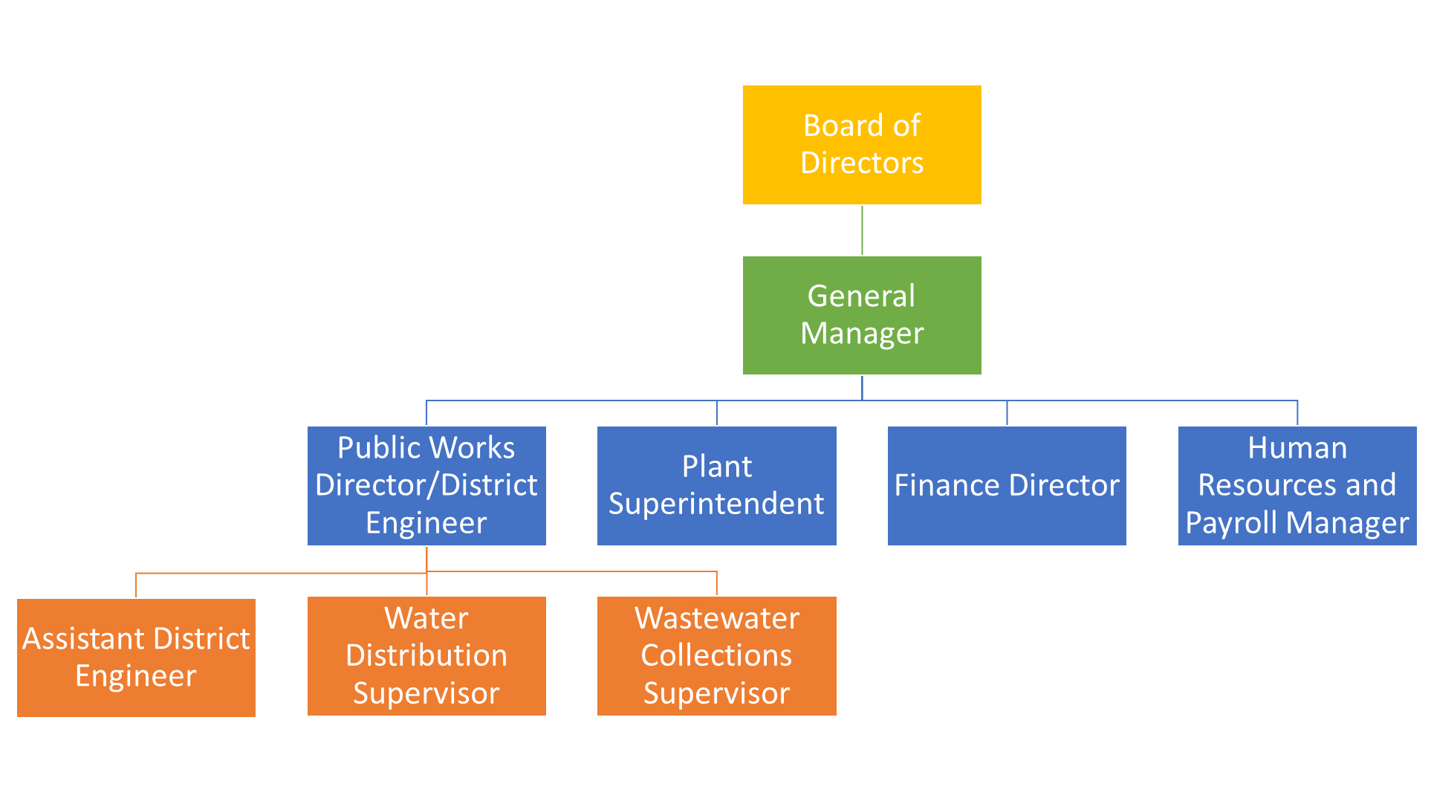

### Continued Public Participation

An open public involvement process is essential to the development of an effective NHMP. Keeping the public informed of efforts to reduce its risk to future natural hazard events is important for successful NHMP implementation and maintenance. OLWS is committed to involving the public in the NHMP review and update process (Volume 1, Section 4).

This will be accomplished by providing NHMP progress updates to our elected officials as part of routine public meetings and work sessions, including updates in future customer newsletters, providing information on the OLWS website and social media, and providing opportunity for review and feedback during our next County and OLWS NHMP update. The link to the OLWS website is [www.OakLodgeWaterServices.org.](http://www.OakLodgeWaterServices.org.)

## NHMP Maintenance

The Clackamas County NHMP and OLWS addendum will be updated every five years in accordance with the update schedule outlined in the Disaster Mitigation Act of 2000. During the County NHMP update process, OLWS will also review and update its addendum (Volume 1, Section 4). The convener will be responsible for convening the HMAC to address the questions outlined below.

* Are there new partners that should be brought to the table?
* Are there new local, regional, state, or federal policies influencing natural hazards that should be addressed?
* Has the community successfully implemented any mitigation activities since the NHMP was last updated?
* Have new issues or problems related to hazards been identified in the community?
* Are the actions still appropriate given current resources?
* Have there been any changes in development patterns that could influence the effects of hazards?
* Have there been any significant changes in the community’s demographics that could influence the effects of hazards?
* Are there new studies or data available that would enhance risk assessment?
* Has the community been affected by any disasters? Did the NHMP accurately address the impacts of this event?

These questions will help the HMAC determine what components of the mitigation plan need updating. The HMAC will be responsible for updating any deficiencies found in the NHMP.

## Mitigation Strategy

The OLWS mitigation strategy (action items) are in the process of being clarified and prioritized, building on the foundation of the Oregon Resilience Plan created in 2013 and gaining clear focus as part of the master planning and assessment efforts recently completed by OLWS. Those efforts include the Water Master Plan (2020), the Wastewater Master Plan (2023), and the Capital Improvement Plan (2023-2028).

Each planning effort involved the identification of hazards and risk, determination of probability and hazard impact, cost analysis, and project selection criteria. Those assessments served as sources for our core mitigation action items. Recent events such as the COVID- 19 pandemic, the extensive nearby wildfire damage in 2020, and localized flooding after recent ice storms recently amplified the recognition and need for increased public preparedness and improved system resilience through natural hazard mitigation.

The action items were identified, prioritized, and relocated to this addendum. They will be revised during subsequent Clackamas County NHMP updates and integrate risk, identified issues, and accomplishments.

## Risk Assessment

This section of the NHMP addendum addresses 44 CFR 201.6(b)(2) – Risk Assessment. In addition, this chapter can serve as the factual basis for addressing Oregon Statewide Planning Goal 7 – Areas Subject to Natural Hazards. Assessing natural hazard risk is defined as the potential for damage, loss, or other impacts created by hazards acting on community assets. The planning team conducted a risk assessment to determine the potential impacts of the hazards to the assets of the community. Ultimately, the goal of hazard mitigation is to reduce the area of risk where hazards overlap vulnerable systems.

While there are multiple methodologies for performing a risk analysis, generally, risk assessment has three phases:

* Phase 1 – Hazard Identification: Identify hazards that can affect the jurisdiction. This includes an evaluation of potential hazard impacts – type, location, extent, etc. and gathering/updating of information required to accurately address hazards.
* Phase 2 – Vulnerability Assessment: Identification of important community assets and system vulnerabilities. Example vulnerabilities include people, businesses, homes, roads, historic places and drinking water sources.
* Phase 3 – Risk Analysis: Evaluate the extent to which the identified hazards overlap with or have an impact on the important assets identified by the community.

The local level rationale for the identified mitigation strategies (action items) is presented herein and within Volume I, Section 3 and Volume III, Appendix C. The risk assessment process is graphically depicted in Figure SA-1. Ultimately, the goal of hazard mitigation is to reduce the area of risk, where hazards overlap vulnerable systems.

Figure OLWS-2: Understanding Risk

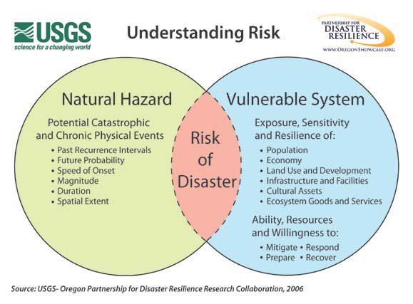

Source: USGS – Oregon Partnership for Disaster Resilience Research Collaboration, 2006

### Hazard Analysis

Using information from Clackamas County’s Hazard Vulnerability Assessment (HVA), OLWS HMAC developed a hazard vulnerability assessment (HVA). Changes from the County’s HVA were made where appropriate to reflect distinctions in vulnerability and risk from natural hazards unique to OLWS, which are discussed throughout this addendum.

Table OLWS-1 shows the HVA matrix for OLWS listing each hazard in order of rank from high to low. The table shows that hazard scores are influenced by each of the four categories combined. For local governments, conducting the hazard analysis is a useful step in planning for hazard mitigation, response, and recovery. The method provides the jurisdiction with sense of hazard priorities but does not predict the occurrence of a hazard. See Volume I, Section 2: Risk Assessment of the Clackamas County NHMP for a description of the methodology.

Cascadia Subduction Zone earthquakes, crustal earthquakes, and flooding rank as the top hazards to OLWS (Top Tier). Winter storms, wildfires, windstorm and pandemic rank in the middle (middle tier). Drought, harmful algal blooms, volcanic events, and landslides comprise the lowest ranked hazards (Bottom Tier).

|  |  |  |  |  |  |  |  |
| --- | --- | --- | --- | --- | --- | --- | --- |
| **Table OLWS-1 Hazard Analysis Matrix** | | | | | | | |
| **Hazard** | **History** | **Vulnerability** | **Maximum Threat** | **Probability** | **Total Threat Score** | **Hazard Rank** | **Hazard Tiers** |
| Earthquake (Cascadia) | 4 | 45 | 100 | 49 | 198 | #1 | *Top Tier* |
| Earthquake (Crustal) | 6 | 50 | 100 | 21 | 177 | #2 |
| Flood | 16 | 30 | 70 | 56 | 172 | #3 |
| Winter Storm | 14 | 30 | 70 | 56 | 170 | #4 | *Middle Tier* |
| Wildfire | 16 | 25 | 65 | 46 | 152 | #5 |
| Windstorm | 14 | 15 | 50 | 42 | 121 | #6 |
| Pandemic | 10 | 45 | 50 | 14 | 119 | #7 |
| Drought | 10 | 15 | 50 | 42 | 117 | #8 | *Bottom Tier* |
| Harmful Algal Blooms | 10 | 15 | 40 | 28 | 93 | #9 |
| Volcanic Event | 2 | 20 | 50 | 14 | 86 | #10 |
| Landslide | 6 | 15 | 20 | 21 | 62 | #11 |
| *Source: Oak Lodge Water Services HMAC, 2023.* | | | | | | | |

### Community Characteristics

This section provides information on OLWS specific demographics and assets by area. Many of these community characteristics can affect how natural hazards impact communities, and how communities choose to plan for natural hazard mitigation.

#### System Overview

Oak Lodge Water Services Authority (OLWS) is joint water and sanitary services authority organized under Chapter 450 of the Oregon Revised Statutes (ORS). OLWS serves a population of about 29,000 directly, providing drinking water, wastewater, and watershed protection services over a 6.5 square mile service area.

OLWS provides drinking water and wastewater services to over 9,100 customer connections and operates and maintains a pipe system consisting of approximately 200 miles of transmission and distribution pipeline, 846 manholes, 5 lift stations, 3123 catch basins, 1.5 billion gallons of wastewater treated each year, and 15.6 million gallons of water storage, and 773 fire hydrants within unincorporated Clackamas County.

The service area encompasses parts of unincorporated Clackamas County, including areas adjacent to Milwaukie and Gladstone, and the areas of Oak Grove and Jennings Lodge. Customers in the OLWS service area receive water that is produced by the North Clackamas County Water Commission’s water treatment plant, and the majority of customers have their wastewater treated and cleaned by the OLWS wastewater treatment plant.

The Clackamas River is the main source of water for the OLWS service areas. Raw river water comes into the 20.0 million gallons per day (MGD) treatment plant by gravity through fish screens into a 38-foot-deep caisson. The water is then pumped up and out to slow sand filters and/or membrane filters. When using the membrane filters, Aluminum Chlorohydrate is added to create a pin flock to better aid in filtration. The slow sand filters are made up of a 12-inch layer of gravel with 36 inches of sand on top. The filters work using the top six inches of the sand, which includes a biological community of organisms that consume the pathogenic organisms coming from the raw river water. Alternatively, the mechanical membranes filter the pathogens out. After filtration, Sodium Carbonate is added to raise the pH of the water, and Sodium Hypochlorite is added for disinfection. The water then goes through a baffled clearwell to create contact time with Chlorine for complete disinfection of the water.

Finished water is pumped from the clearwell to residential and commercial OLWS customers, other water providers, and throughout the system for fire protection. Reservoirs throughout the distribution network provide additional storage and gravity feed to customers.

#### Water Rights

OLWS is a member of the Clackamas River Water Providers, a group of agencies that separately hold water rights along the Clackamas River. This group consists of the North Clackamas County Water Commission (NCCWC – which includes Oak Lodge Water Services Authority, Sunrise Water Authority and the City of Gladstone), Clackamas River Water, South Fork Water Board (which includes the Cities of West Linn and Oregon City), the City of Lake Oswego, the City of Tigard, and the City of Estacada. Most of the cities noted are part of the County NHMP. As of July 1, 1970 NCCWC holds a non-certificated surface water right authorizing the total use of up to 40.07 MGD from the Clackamas River for municipal use. The surface water right is junior to three in-stream rights along the Clackamas River. At this time the NCCWC water treatment plant has a production capacity of 10 MGD, which limits the amount of water used from the surface water right.

#### Interconnections with other Systems

OLWS’s drinking water system is interconnected with several other public water systems (e.g., wholesale water and emergency interties) that allow the exchange of water during emergency or water shortage events. OLWS will continue to look for mitigation opportunities to implement emergency interconnections with neighboring water providers.

NOTE: Figure OLWS-3 is a map of the OLWS service area. Specific asset locations are not shown to protect the security of the system.

Figure OLWS-3 Oak Lodge Water Services Service Area

*Source: Oak Lodge Water Services - Water System Master Plan (2019)*

#### Transportation/Infrastructure

OLWS relies on the Clackamas County Department of Transportation and Development to maintain the local road system. Tri-Met Transportation provides bus and Max train service for the OLWS area.

#### Economy

The economic integrity of OLWS is made up of blue and white collar families, retirees, and mixed businesses. The local economy relies on local small businesses as well as larger franchises including grocers, health care, fast food, a preponderance of automotive focused dealerships, among others.

### Community Assets

Considering OLWS’s specific assets during the planning process can assist in identifying appropriate measures for natural hazard mitigation. OLWS’s assets were identified as part of the 2023 HMAC NHMP review. Table OLWS-2 lists the resources, facilities, and infrastructure that, if damaged, could significantly impact the public safety, economic conditions, and environmental integrity of OLWS.

|  |  |  |  |  |  |  |  |  |  |  |  |
| --- | --- | --- | --- | --- | --- | --- | --- | --- | --- | --- | --- |
| **Table OLWS-2. Asset Summary** | | | | | | | | | | | |
| **Name/Number** | **Area** | **Identified Hazard Exposure** | | | | | | | | | |
| **DR** | **EQ** | **FL** | **HB** | **PA** | **LS** | **VE** | **WF** | **WN** | **WS** |
| Wastewater Treatment Plant | Renton |  | X |  |  |  | X |  | X | X | X |
| Pump Station #2 | Oak Shore Ln |  | X |  |  |  | X |  | X | X | X |
| Pump Station #3 | Park Ave |  | X |  |  |  |  |  | X | X | X |
| Pump Station #4 | River Forest Ln |  | X |  |  |  |  |  | X | X | X |
| Pump Station #5 | Walta Vista Dr |  | X |  |  |  |  |  | X | X | X |
| Pump Station #6 | Glen Echo |  | X |  |  |  |  |  | X | X | X |
| Pipelines/Distribution System | - |  | X | X |  |  | X |  |  |  | X |
| Reservoir 1 & 2 | Valley View | X | X |  |  |  | X |  | X | X | X |
| Reservoir 3 & 4 | View Acres | X | X |  |  |  | X |  | X | X | X |
| Other Assets | | | | | | | | | | | |
| Back-up Generators | - |  | X |  |  |  |  |  |  |  |  |
| Administration Buildings | - |  | X |  |  |  | X |  | X |  |  |
| OLWS Staff | - |  | X |  |  | X |  |  |  |  | X |
| Supervisory Control and Data Acquisition (SCADA) System | - |  | X |  |  |  |  |  |  | X | X |
| Business/Information Technology System | - |  | X |  |  |  |  |  |  | X | X |
| *Source: Information provided by Oak Lodge Water Services* | | | | | | | | | | | |
| *Hazard Descriptions: DR = Drought*  *EQ = Earthquake*  *FL = Flood* | *HB = Harmful Algal Blooms*  *PA = Pandemic*  *LS = Landslide*  *VE = Volcanic Event* | | | | *WF = Wildfire*  *WN = Windstorm/Tornado*  *WS = Winter Storm* | | | | | | |

#### Critical Facilities

Facilities that are critical to government response, and recovery activities (i.e. life, safety, property, and environmental protection). These facilities include: 911 Centers, Emergency Operations Centers, Police, and Fire Stations, Public Works facilities, sewer, and water facilities, hospitals, bridges, roads, shelters, and more.

#### Critical Infrastructure

Infrastructure that provides necessary services for emergency response include: services for Clackamas County and Clackamas Fire District.

#### Essential Facilities

Facilities that are essential to the continued delivery of key government services, and/or that may significantly impact the public’s ability to recover from the emergency. These facilities may include: OLWS buildings such as the Administration Building, pump stations, the OLWS Wastewater Treatment Plant, and other public facilities such as schools.

#### Environmental Facilities

Environmental assets are those parks, green spaces, wetlands, and rivers that provide an aesthetic, and functional ecosystem services. Service areas functioning for the community include: Boardman Wetlands Nature Park, Rivervilla Park, Stringfield Park, the Trolley Trail, and the Willamette River.

#### Vulnerable Populations

Vulnerable populations, including seniors, disabled citizens, women, and children, as well those people living in poverty, often experience the impacts of natural hazards and disasters more acutely. Populations that have special needs or require special consideration include: seniors, disabled residents, families with children, and residents living at or below the poverty line.

#### Hazardous Materials

Facilities that, if damaged, could cause serious secondary impacts may also be considered “critical.” Hazardous materials sites are particularly vulnerable to earthquake, landslide, volcanic event, wildfire, and winter storm hazards. A hazardous material facility is one example of this type of critical facility. Those sites that store, manufacture, or use potentially hazardous materials include: certain businesses located along 99E or within the boundaries of OLWS.

#### Economic Assets/Population Centers

Economic assets include businesses that employ large numbers of people and provide an economic resource to OLWS. If damaged, the loss of these economic assets could significantly affect economic stability, and prosperity. Population Centers usually are aligned with economic centers and are a concern during evacuation/notification. Economic/Population centers that would cause concern during a hazard event include: Oak Grove Fred Meyer and the businesses located along 99E.

#### Cultural and Historic Assets

The cultural and historic heritage of a community is more than just tourist charm. For families that have lived in the area for generations and new residents alike, it is the unique places, stories, and annual events that make the community an appealing place to live. The cultural and historic assets are both intangible benefits and obvious quality-of-life-enhancing amenities. Because of their role in defining and supporting the community, protecting these resources from the impact of disasters is important.

### Hazard Characteristics

Volume I, Section 2 of the Clackamas County NHMP thoroughly describes the characteristics of the profiled hazards, history, as well as the location, extent, and probability of potential events within the County. Generally, an event that affects the County, or applicable areas where OLWS facilities are located, is likely to affect OLWS as well. Similarly, the causes and characteristics of hazard events are appropriately described within Volume 1, Section 2 as well as the location and extent of potential hazards. Lastly, previous occurrences are well documented within Volume 1, Section 2 and the community impacts described by the County, or applicable City, would generally be the same for OLWS.

Table OLWS-3 lists the various natural hazards in the general Clackamas County area which are applicable to OLWS, along with any observed impacts associated with the historical occurrence of such events within the OLWS service boundary.

|  |  |
| --- | --- |
| **Table OLWS-3. Natural Hazards** | |
| **Hazard** | **Description and Historical Occurrence** |
| Drought | * Drought is a hazard of increasing concern in Western States. OLWS is concerned about drought in that it reduces the quantity of water available and increases the risk of wildfires. Wildfires may impact facilities and staff but may also cause acute and chronic water quality concerns. * A historical occurrence of drought impacted operations and triggered Water Management and Conservation plan curtailments on the Clackamas River in 2015. |
| Earthquakes (including liquefaction, crustal and landslide) | * Earthquake hazards encompass effects from liquefaction, a phenomenon where saturated sand and silt take on the characteristics of a liquid during the intense shaking of an earthquake, and landslide. * OLWS and Clackamas County are within the area of impact of the Cascadia subduction zone. Crustal faults are located within Clackamas County. * There have been instances of water lines and facilities impacted by earthquake induced landslides, including the potential impact to the main water transmission pipe located in soil that has the potential for liquefaction during earthquakes. |
| Flood | OLWS assets are in an area that is susceptible to flooding from the Willamette River. The OLWS Wastewater Treatment Plant is barely above the 100-year flood level.  According to the National Weather Service, there have been several river crests between 26 and 30 feet from 1956-2023. Where the river level is typically under 7 feet in February, during the flood of 1996, the river crested at 28.55 ft. It flooded the OLWS influent pump station which had to be shut down for approximately 24 hours due to the nature of the floodwater inundation. Flood stage is 18 feet.  Flooding also occurs from streams emanating from Oatfield Ridge (Rinearson, Boardman, and River Forest Creeks and their tributaries. These floods are sometimes chronic and block roadways and affect property. They can be exacerbated by increases in impervious surfaces from development (both current development and development predating stormwater standards in 1993), loss of wetlands, increasing severity of storms due to climate change, and undersized infrastructure (i.e. culverts) and inadequate maintenance of facilities such as stormwater treatment facilities and/or culverts. |
| Harmful Algal Blooms | * Harmful algal blooms (HABs) occur when colonies of algae grow rapidly, release toxins or deplete oxygen levels and can become harmful to plants, animals and humans. HABs with cyanotoxins that includes Benthic algae have been detected upstream of the NCCWC Water Treatment Plant in North Fork Reservoir and Timothy Lake in the Clackamas River Watershed during low flow and high heat conditions almost every summer. * HABS are an annual occurrence at River Forest Lake, posing a hazard to pets and people. |
| Pandemic | * A pandemic is an epidemic of infectious disease that has spread over a large region. * COVID 19 was an unprecedented example of a pandemic which has had widespread global implications. * The most recent pandemic in 2020-21 impacted operations due to varied work   schedules for OLWS staff to slow or stop the potential for infection. |
| Volcanic Event | * OLWS is located near two active volcanoes; Mount Hood and Mount St. Helens, however OLWS’s assets are not in an area that is susceptible to volcanic proximity hazards (lava flow and lahars etc.) but is subject to ash fall. * Upstream lahars are not expected on the Clackamas River since there is no direct access to volcanos in the upper watershed. * Ash fall impacted drinking water treatment at the NCCWC treatment plant during the eruption of Mount St Helens in 1980. |
| Wildfire | * Topography, fuel (vegetation), and weather contribute to wildfire potential. * Wildfires are an increasingly common occurrence in the west. OLWS is in an area that is at high risk for natural or human caused wildfire.   Recent fires include the nearby 36 Pit Fire in September 2014, the Riverside Fire and the Elk Rock Island fire in 2020. |
| Windstorm | * Windstorms which bring damaging high-speed winds have been recorded in the area. Windstorms, combined with drought, wildfire risk, and climate and pest induced tree weakness (Emerald Ash Borer, Western Redcedar dieoff) can increase risk of power outages from falling trees/limbs, and wildfire from downed power lines. * Annual historical high wind occurrences have caused short term power outages. |
| Severe Weather  e.g. Winter Storm | * Winter Storms or deep freezes which cause damage to pipes and other assets have been recorded in the area. Recent snow and ice storms occurred in 2004 and 2017. * Typical impacts include frozen meters and sensing lines, ruptured pipes and short-term power outages normally lasting less than 24 hours. During the winter snow/ice storm in February 2023 there was restricted critical infrastructure site access and power failures that impacted operations for multiple days. |

# Attachment A: Action Item Forms

## Summary of Action Changes

A summary list of mitigation actions for OLWS is provided in Table OLWS-9. Each action item has a corresponding action item worksheet describing the activity, identifying the rationale for the project, identifying potential ideas for implementation, and assigning coordinating and partner organizations. The action item worksheets can assist OLWS in pre-packaging potential projects for grant funding. The worksheet components are described below.

## Action Item Forms

Each action item has a corresponding action item worksheet or table describing the activity, identifying the rationale for the project, identifying potential ideas for implementation, identifying potential mitigation funds, and assigning lead organizations or agencies. The action item worksheets can assist the community in pre-packaging potential projects for grant funding. The worksheet components are described below.

### Action Item Description

To be updated. Will be provided by the County once completed.

### Ideas for Implementation (High Priority)

The ideas for implementation offer a transition from theory to practice and serve as a starting point for this plan. This component of the action item is dynamic, since some ideas may prove to not be feasible, and new ideas may be added during the plan maintenance process. Ideas for implementation include such things as collaboration with relevant organizations, grant programs, tax incentives, human resources, education and outreach, research, and physical manipulation of buildings and infrastructure.

### Lead Organization or Agency

The coordinating organization is the public agency with the regulatory responsibility to address natural hazards, or that is willing and able to organize resources, find appropriate funding, or oversee activity implementation, monitoring and evaluation.

### Potential Funding Source

Where possible potential funding sources have been identified. Example funding sources may include: Federal Hazard Mitigation Assistance programs, state funding sources such as the Oregon Seismic Rehabilitation Grant Program, or local funding sources such as capital improvement or general funds. An action item may include several potential funding sources.

### Climate Change Related (High Priority)

The impacts of climate change includes not just changes in the severity and regularity of natural hazards, but also changes in population patterns (migration, density, and the makeup of socially vulnerable populations), and changes in land use and development. While climate adaptation efforts may be undertaken separately or in addition to the all-hazards mitigation planning process, hazard mitigation and climate adaptation are complementary efforts that have the same goal: long-term risk reduction for people and increased safety for communities. Consider how the impacts of the Action Item will enhance climate change adaptation and how by implementing these strategies will reduce e risk to and mitigate impacts from actual or expected causes of climate change.

### Community Lifelines (High Priority)

Community lifelines are the most fundamental services in the community that, when stabilized, enable all other aspects of society to function. Consider which lifelines your project reduces the most risk to, and in turn, enhances the overall resilience of your community. Community Lifelines include the following categories and examples:

* **Safety and Security**
  + Law enforcement/security
  + Fire service
  + Government Service (e.g., EOC, schools, historic/cultural resources)
  + Community Safety (e.g., flood control, protective actions)
* **Food, Water, Shelter**
  + Food (e.g., Food distribution and supply chain)
  + Water (e.g., drinking water utilities, wastewater systems)
  + Shelter (e.g., housing, commercial facilities)
  + Agriculture
* **Health and Medical**
  + Medical care (e.g., hospitals, pharmacies, veterinary services)
  + Public Health
  + Medical supply chain
* **Energy**
  + Power grid
  + Fuel (e.g., fuel storage, fuel distribution)
* **Communications**
  + Infrastructure
  + Finance (e.g., Banking services)
* **Transportation**
  + Highway/Roadway/Motor Vehicle
  + Mass Transit
  + Railway
  + Aviation
* **Hazardous Material**
  + Facilities

### Population Impact (High Priority)

Action Items have the potential to affect the community and the population to some extent, either by reducing the impact of natural hazards on social and economic issues or enhancing the accessibility of marginalized populations to resources and services related to disaster preparedness and mitigation. However, an Action Item may produce unintended consequences and contribute to disproportionate environmental stressors and burdens on marginalized communities. For example, recommendations for changes to development codes may adversely affect low-income housing locations. Therefore, it is important to consider the impact of an Action Item on the community as a result of its implementation, whether it be negative or positive. Below is a list of potential community aspects that the Action Item may impact, whether positively or negatively.

* Limited water and sanitation access and affordability
* High and/or persistent poverty
* Rural community
* Jobs lost through the energy transition
* High energy cost burden and low energy access
* Racial and ethnic segregation particularly where the segregation stems from discrimination by government entities
* High unemployment and underemployment
* High housing cost burden and substandard housing
* Low income
* Limited access to health care
* Linguistic isolation
* Distressed neighborhoods
* Disproportionate impacts from climate
* All geographic areas within Tribal jurisdictions
* High transportation cost burden and/or low transportation access
* Disproportionate environmental stressor burden and high cumulative impacts

### Community Impact (Low/Medium Priority)

This section examines and assesses how the Action Item will affect the broader community by summarizing the content presented in the High Priority Action Item Template sections: Climate Change Related, Community Lifelines, and Population Impact. The Community Impact categories align with the NHMP Mission and Goals (listed above) and the categories and description are as follows:

* **Protect Life:** Does the Action Item strive to protect life and reduce injuries to community members from natural hazards?
* **Community Lifelines:** Does the Action Item impact/benefit one of the Community?
* **Climate Adaptation:** Does the Action Item integrate/align natural hazards mitigation and climate adaptation efforts based on the evolving understanding of the interrelationships between climate change and climate-related natural hazard events?
* **Enhance Communication:** Enhance communication, collaboration, and coordination among agencies at all levels and region of government, sovereign tribal nations, the private sector, and community members to mitigate natural hazards.
* **Vulnerable Populations:** Does the Action Item mitigation the inequitable impacts of natural hazards to the vulnerable populations and the communities that reside or utilize your community?
* **Encourage Resilient Development:** Does the Action Item strive to encourage new development to adhere to more resilient practices, so as to promote more functional recovery?
* **Environmental Impact:** Does the Action Item minimize natural hazards’ impact on environmental and ecological systems?
* **Historical and Cultural:** Does the Action Item minimize the damage from natural hazards to historic and cultural resources?
* **Repetitive Losses:** Does the Action Item reduce/minimize the damage to/exposure of structures and properties that are identified as repetitive and severe repetitive flood losses?
* **Dams Posing Risk:** Minimize or eliminate potential impacts from dams posing the greatest risk to people, property, and infrastructure?

### Timeline

All broad scale action items have been determined to be ongoing, as opposed to short-term (0 to 2 years), medium-term (3 to 4 years), and long-term (5 or more years). This is because the action items are broad ideas, and although actions may be implemented to address the broad ideas, the efforts should be ongoing.

### Estimated Cost

A rough estimate of the cost for implementing each action item is included. Costs are shown in general categories showing low, medium, or high cost. The estimated cost for each category is outlined below:

Low - Less than $50,000

Medium - $50,000 – $100,000

High - More than $100,000

|  |  |  |  |  |  |  |  |  |  |  |  |
| --- | --- | --- | --- | --- | --- | --- | --- | --- | --- | --- | --- |
| **Table OLWS-4 Action Item Summary** | | | | | | | | | | | |
| **Action Item** | **Description** | **Timeline** | **Drought** | **Earthquake** | **Flood** | **Harmful Algal Blooms** | **Pandemic** | **Volcanic Event** | **Wildfire** | **Windstorm/Tornado** | **Winter Storm** |
| OLWS #1 | Conduct Seismic Analysis of Water Main Supply | Short |  | X |  |  |  |  |  |  |  |
| OLWS #2 | Backup Generator at Water Pump Station | Short |  | X |  |  |  |  | X |  | X |
| OLWS #3 | Emergency Water Intertie with City of Milwaukie | Long | X | X |  |  |  |  | X | X | X |
| OLWS #4 | Wastewater Mainline Rain-Derived Inflow and Infiltration | Long |  | X |  |  |  |  |  |  |  |
| OLWS #5 | Boardman and Arista Flood Mitigation | Medium |  |  | X |  |  |  |  |  |  |
| OLWS #6 | Update Data Layers Needed for Flood Attenuation | Short/ Medium |  |  | X |  |  |  |  |  |  |
| OLWS #7 | Conduct Assessment of Best Locations for Floodplain Reconnection and Flood Attenuation | Short/ Medium |  |  | X |  |  |  |  |  |  |
| OLWS #8 | Fire Flow Improvements | Long |  | X |  |  |  |  | X |  |  |
| OLWS #9 | Fleet Resiliency Program | Long | X | X | X |  |  |  | X | X | X |
| OLWS #10 | Seismic Backbone Replacement Program | Long |  | X |  |  |  |  | X |  |  |

|  |  |  |  |  |  |  |  |
| --- | --- | --- | --- | --- | --- | --- | --- |
| **Mitigation Action: OLWS #1**  **(What do we want to do?) Conduct Seismic Analysis of Water Main Supply** | | | | | | **High Priority Action** | |
| Multi-Hazard | Drought | | Earthquake | | Flood | | Landslide |
| Volcanic Event | Wildfire | | Extreme Heat | | Winter Storm | | Windstorm |
| Statement | | Conduct In-Depth Seismic Analysis of OLWS’s 24-inch water supply pipeline. Seismic Analysis is aligned with OLWS’s AWIA Risk and Resilience Assessment, Water System Master Plan and Oregon Resilience Plan. | | | | | |
| Description | | As part of the goals of the 2013 Oregon Resilience Plan, water utilities will develop a 50-year mitigation plan for resilience to the impact of the Cascadia Subduction Zone Earthquake, (CSZE), magnitude 9.0. The development of this mitigation plan is required under Oregon Administrative Rule 333-061-0060 (5) (J). This includes seismic upgrades to critical assets of the water utility, including the water supply line from the North Clackamas County Water Commission.  Project is listed in 2023 Capital Improvement Plan to be conducted. The next step is to commission a study to conduct detailed structural, non-structural, and geotechnical evaluation of the OLWS supply line. | | | | | |
| Potential Implementation | | Commission a qualified professional to determine the extent to which the water supply line is adequately designed and constructed to resist seismic forces. Following completion of the evaluation, results will be used to prioritize recommended upgrades to assets within the capital improvement program. | | | | | |
| Lead | | OLWS Engineering | | | | | |
| Potential Hazard Mitigation Grant | | Yes | | | | | |
| Climate Change Related | | No | | | | | |
| Community Lifelines | | Yes | | | | | |
| Population Impact | | 29,000+ | | | | | |
| Estimated Cost | | | | Timing | | | |
| Low (Less than $50,000)  Medium ($50,000 to $100,000)  High ($100,000 or more) | | | | Ongoing  Short Term (0 to 2 years)  Medium Term (3 to 5 years)  Long Term (More than 5 years) | | | |

|  |  |  |  |  |  |  |  |
| --- | --- | --- | --- | --- | --- | --- | --- |
| **Mitigation Action: OLWS #2**  **(What do we want to do?) Backup Generator at Water Pump Station** | | | | | | **High Priority Action** | |
| Multi-Hazard | Drought | | Earthquake | | Flood | | Landslide |
| Volcanic Event | Wildfire | | Extreme Heat | | Winter Storm | | Windstorm |
| Statement | | Provide backup power source for OLWS potable water pump station at Clackamas River Water treatment plant, the secondary source for OLWS water supply. | | | | | |
| Description | | Resiliency enhancements are aligned with OLWS’s AWIA Risk and Resilience Assessment and Oregon Resilience Plan (2013).  Many of the events that can interrupt the delivery of treated drinking water to OLWS can be regional, such as grid-wide power failure following a storm. Resiliency to such events is upheld with redundant water sources and independent backup power. These measures keep fresh water flowing for drinking and fire suppression when the water supply may be needed the most.  Project is listed in 2023 Capital Improvement Plan to be conducted. Next steps would be to commission a qualified professional to assess the current pump station requirements for backup power. | | | | | |
| Potential Implementation | | Commission a qualified professional to size and install the backup generator and associated components to provide emergency power to the OLWS pump station at the Clackamas River Water treatment plant. | | | | | |
| Lead | | OLWS Engineering | | | | | |
| Potential Hazard Mitigation Grant | | Yes | | | | | |
| Climate Change Related | | Yes | | | | | |
| Community Lifelines | | Yes | | | | | |
| Population Impact | | 29,000+ | | | | | |
| Estimated Cost | | | | Timing | | | |
| Low (Less than $50,000)  Medium ($50,000 to $100,000)  High ($100,000 or more) | | | | Ongoing  Short Term (0 to 2 years)  Medium Term (3 to 5 years)  Long Term (More than 5 years) | | | |

|  |  |  |  |  |  |  |  |
| --- | --- | --- | --- | --- | --- | --- | --- |
| **Mitigation Action: OLWS #3**  **(What do we want to do?) Emergency Water intertie with City of Milwaukie** | | | | | | **High Priority Action** | |
| Multi-Hazard | Drought | | Earthquake | | Flood | | Landslide |
| Volcanic Event | Wildfire | | Extreme Heat | | Winter Storm | | Windstorm |
| Statement | | A booster pump station and upsized pipe could be used to pump water from Milwaukie’s lower zone to OLWS’s lower zone to fill the Valley View tanks. | | | | | |
| Description | | Installation of an emergency water intertie with the City of Milwaukie is aligned with OLWS’s AWIA Risk and Resilience Assessment, Water System Master Plan and Oregon Resilience Plan.  With a single source of supply through the 24‐inch pipeline from the NCCWC, the District is vulnerable to an outage caused by an unplanned pipe break. Portions of the pipeline closer to the Clackamas River are expected to have an increased risk of breakage due to lateral spreading and liquefaction induced settlement.  OLWS’s Water System Master Plan identifies a need to focus on a seismic standard based pipe replacement program. OLWS has identified pipelines to be replaced and seismic standards are in development. | | | | | |
| Potential Implementation | | Commission a qualified professional for a preliminary design to refine the locations, costs, agreements, and permits required for construction of the proposed emergency intertie. | | | | | |
| Lead | | OLWS Engineering and Distribution | | | | | |
| Potential Hazard Mitigation Grant | | Yes | | | | | |
| Climate Change Related | | Yes | | | | | |
| Community Lifelines | | Yes | | | | | |
| Population Impact | | 29,000+ | | | | | |
| Estimated Cost | | | | Timing | | | |
| Low (Less than $50,000)  Medium ($50,000 to $100,000)  High ($100,000 or more) | | | | Ongoing  Short Term (0 to 2 years)  Medium Term (3 to 5 years)  Long Term (More than 5 years) | | | |

|  |  |  |  |  |  |  |  |
| --- | --- | --- | --- | --- | --- | --- | --- |
| **Mitigation Action: OLWS #4**  **(What do we want to do?) Wastewater Mainline Rain-Derived Inflow and Infiltration** | | | | | | | **High Priority Action** |
| Multi-Hazard | Drought | | Earthquake | | Flood | Landslide | |
| Volcanic Event | Wildfire | | Extreme Heat | | Winter Storm | Windstorm | |
| Statement | | Reduce rain-derived inflow and infiltration to prevent sanitary sewer outflows through rehabilitation of manholes and wastewater pipes. | | | | | |
| Description | | Rehabbing OLWS’s wastewater mainlines to reduce sanitary sewer outflows (SSO’s) and increase earthquake resiliency through upgrading pipe material is aligned with OLWS’s AWIA Risk and Resilience Assessment, Wastewater Master Plan and Oregon Resilience Plan.  Deficient infrastructure in the wastewater conveyance system leads to rainfall-derived Infiltration and Inflow (RDII) when rainwater makes its way into the collections system and mixes with the wastewater. Additionally, a significant seismic event would likely lead to collapsed pipes and wastewater backups. Upgrading and rehabbing aging infrastructure with more resilient pipe materials will reduce or eliminate failures due to seismic events and decrease RDII that leads to sanitary sewer outflows.  Consultant is currently reviewing CCTV footage to provide recommendations for rehab and tentative timelines. | | | | | |
| Potential Implementation | | Commission a qualified professional for a preliminary design to refine the specific rehab options, locations, and costs. | | | | | |
| Lead | | OLWS Engineering | | | | | |
| Potential Hazard Mitigation Grant | | Maybe | | | | | |
| Climate Change Related | | Yes | | | | | |
| Community Lifelines | | Yes | | | | | |
| Population Impact | | 29,000+ | | | | | |
| Estimated Cost | | | | Timing | | | |
| Low (Less than $50,000)  Medium ($50,000 to $100,000)  High ($100,000 or more) | | | | Ongoing  Short Term (0 to 2 years)  Medium Term (3 to 5 years)  Long Term (More than 5 years) | | | |

|  |  |  |  |  |  |  |  |
| --- | --- | --- | --- | --- | --- | --- | --- |
| **Mitigation Action: OLWS #5**  **(What do we want to do?) Boardman and Arista Flood Mitigation** | | | | | | **High Priority Action** | |
| Multi-Hazard | Drought | | Earthquake | | Flood | | Landslide |
| Volcanic Event | Wildfire | | Extreme Heat | | Winter Storm | | Windstorm |
| Statement | | Address repeat flooding hazards caused by flat grades and beaver dams. | | | | | |
| Description | | Fixing flooding issues are aligned with OLWS’s AWIA Risk and Resilience Assessment, Stormwater Management Plan and Oregon Resilience Plan.  Recognized as one of the OLWS's worst flooding spots, this site repeatedly floods the Trolley Trail, Boardman Avenue, Arista Drive and private property. Currently, it is suspected that beaver dams and flat grades cause a majority of the flooding. By fixing flooding issues within the service area it improves environmental health, livability, and property values. These types of projects also help OLWS's MS4 Annual commitments to treating stormwater.  This project is in the planning stage, with partners including the North Clackamas Watersheds Council (NCWC). | | | | | |
| Potential Implementation | | Collaboration with affected parties/ jurisdictions to determine a long-term solution to flooding. | | | | | |
| Lead | | OLWS Engineering and NCWC | | | | | |
| Potential Hazard Mitigation Grant | | Yes | | | | | |
| Climate Change Related | | Yes | | | | | |
| Community Lifelines | | Yes | | | | | |
| Population Impact | | 29,000+ | | | | | |
| Estimated Cost | | | | Timing | | | |
| Low (Less than $50,000)  Medium ($50,000 to $100,000)  High ($100,000 or more) | | | | Ongoing  Short Term (0 to 2 years)  Medium Term (3 to 5 years)  Long Term (More than 5 years) | | | |

|  |  |  |  |  |  |  |  |
| --- | --- | --- | --- | --- | --- | --- | --- |
| **Mitigation Action: OLWS #6**  **(What do we want to do?) Update Data Layers Needed for Flood Attenuation** | | | | | | **High Priority Action** | |
| Multi-Hazard | Drought | | Earthquake | | Flood | | Landslide |
| Volcanic Event | Wildfire | | Extreme Heat | | Winter Storm | | Windstorm |
| Statement | | Updated data layers are needed to address repeat flooding hazards caused by flat grades and beaver dams. | | | | | |
| Description | | Fixing flooding issues are aligned with OLWS’s AWIA Risk and Resilience Assessment, Stormwater Management Plan and Oregon Resilience Plan.  There are multiple locations of chronic flooding in OLWS, including the Boardman and Arista Project #5. Currently, it is suspected that the addition of upstream impervious surfaces, infill, flat grades and channelization cause a majority of the flooding, along with larger winter storms exacerbated by beaver activity and undersized culverts. By fixing flooding issues via floodplain reconnection, it improves environmental health, livability, and property values. These types of projects also help OLWS's MS4 Annual commitments to treating stormwater.  This project is in the planning stage, with partners including the North Clackamas Watersheds Council (NCWC). | | | | | |
| Potential Implementation | | Collaboration with affected parties/ jurisdictions to determine a long-term solution to flooding. | | | | | |
| Lead | | OLWS Engineering and NCWC | | | | | |
| Potential Hazard Mitigation Grant | | Yes | | | | | |
| Climate Change Related | | Yes | | | | | |
| Community Lifelines | | Yes | | | | | |
| Population Impact | | 29,000+ | | | | | |
| Estimated Cost | | | | Timing | | | |
| Low (Less than $50,000)  Medium ($50,000 to $100,000)  High ($100,000 or more) | | | | Ongoing  Short Term (0 to 2 years)  Medium Term (3 to 5 years)  Long Term (More than 5 years) | | | |

|  |  |  |  |  |  |  |  |
| --- | --- | --- | --- | --- | --- | --- | --- |
| **Mitigation Action: OLWS #7**  **(What do we want to do?) Conduct Assessment of Best Locations for Floodplain Reconnection and Flood Attenuation** | | | | | | **High Priority Action** | |
| Multi-Hazard | Drought | | Earthquake | | Flood | | Landslide |
| Volcanic Event | Wildfire | | Extreme Heat | | Winter Storm | | Windstorm |
| Statement | | A comprehensive assessment is needed to address repeat flooding hazards caused by several environmental pressures. | | | | | |
| Description | | Fixing flooding issues are aligned with OLWS’s AWIA Risk and Resilience Assessment, Stormwater Management Plan and Oregon Resilience Plan.  There are multiple locations of chronic flooding in OLWS, including the Boardman and Arista Project #5. Currently, it is suspected that the addition of upstream impervious surfaces, infill, flat grades and channelization cause a majority of the flooding, along with larger winter storms exacerbated by beaver activity and undersized culverts. By fixing flooding issues via floodplain reconnection, it improves environmental health, livability, and property values. These types of projects also help OLWS's MS4 Annual commitments to treating stormwater.  This project is in the planning stage, with partners including the North Clackamas Watersheds Council (NCWC). | | | | | |
| Potential Implementation | | Collaboration with affected parties/ jurisdictions to determine a long-term solution to flooding. | | | | | |
| Lead | | OLWS Engineering and NCWC | | | | | |
| Potential Hazard Mitigation Grant | | Yes | | | | | |
| Climate Change Related | | Yes | | | | | |
| Community Lifelines | | Yes | | | | | |
| Population Impact | | 29,000+ | | | | | |
| Estimated Cost | | | | Timing | | | |
| Low (Less than $50,000)  Medium ($50,000 to $100,000)  High ($100,000 or more) | | | | Ongoing  Short Term (0 to 2 years)  Medium Term (3 to 5 years)  Long Term (More than 5 years) | | | |

|  |  |  |  |  |  |  |  |
| --- | --- | --- | --- | --- | --- | --- | --- |
| **Mitigation Action: OLWS #8**  **(What do we want to do?) Fire Flow Improvements** | | | | | | **High Priority Action** | |
| Multi-Hazard | Drought | | Earthquake | | Flood | | Landslide |
| Volcanic Event | Wildfire | | Extreme Heat | | Winter Storm | | Windstorm |
| Statement | | Upsize water distribution network components to meet fire suppression demands. | | | | | |
| Description | | The fire flow improvements are aligned with OLWS’s AWIA Risk and Resilience Assessment and Oregon Resilience Plan (2013) and the Treatment Plant Facilities Plan (2023).  Water distribution systems must provide adequate protection during a fire. OLWS’s fire flow requirements at each hydrant location are based on the zoning category of the parcels served by the hydrant. Adequate distribution pipe and hydrant sizing is vital to ensure flow requirements are available to address fires.  OLWS is in the planning stages of upsizing distribution pipes and hydrants in conjunction with its main replacement program as defined in the Water System Master Plan. This is a long-term project. | | | | | |
| Potential Implementation | | Commission a qualified professional to further prioritize recommended upgrades to assets within the capital improvement program based on the 2020 Water System Master Plan and other overlapping projects. | | | | | |
| Lead | | OLWS Engineering | | | | | |
| Potential Hazard Mitigation Grant | | Yes | | | | | |
| Climate Change Related | | Yes | | | | | |
| Community Lifelines | | Yes | | | | | |
| Population Impact | | 29,000+ | | | | | |
| Estimated Cost | | | | Timing | | | |
| Low (Less than $50,000)  Medium ($50,000 to $100,000)  High ($100,000 or more) | | | | Ongoing  Short Term (0 to 2 years)  Medium Term (3 to 5 years)  Long Term (More than 5 years) | | | |

|  |  |  |  |  |  |  |  |
| --- | --- | --- | --- | --- | --- | --- | --- |
| **Mitigation Action: OLWS #9**  **(What do we want to do?) Vehicle Resiliency Program** | | | | | | **High Priority Action** | |
| Multi-Hazard | Drought | | Earthquake | | Flood | | Landslide |
| Volcanic Event | Wildfire | | Extreme Heat | | Winter Storm | | Windstorm |
| Statement | | As part of OLWS planning efforts, purchase additional provisional field operations vehicles. | | | | | |
| Description | | A vehicle resiliency program is aligned with OLWS’s AWIA Risk and Resilience Assessment and Oregon Resilience Plan (2013).  As a part of the vehicle resiliency program for OLWS, additional field vehicles are necessary to protect and preserve the water, wastewater, and watershed protection programs and build resiliency resulting in more reliable systems.  Updating budget for future needs is currently in process. | | | | | |
| Potential Implementation | | Purchase additional field operations trucks, backhoe, dump truck, and additional equipment as needed. Forecast vehicle and equipment replacement schedules to ensure reliability of service. | | | | | |
| Lead | | OLWS Engineering | | | | | |
| Potential Hazard Mitigation Grant | | Yes | | | | | |
| Climate Change Related | | Yes | | | | | |
| Community Lifelines | | Yes | | | | | |
| Population Impact | | 29,000+ | | | | | |
| Estimated Cost | | | | Timing | | | |
| Low (Less than $50,000)  Medium ($50,000 to $100,000)  High ($100,000 or more) | | | | Ongoing  Short Term (0 to 2 years)  Medium Term (3 to 5 years)  Long Term (More than 5 years) | | | |

|  |  |  |  |  |  |  |  |
| --- | --- | --- | --- | --- | --- | --- | --- |
| **Mitigation Action: OLWS #10**  **(What do we want to do?) Seismic Backbone Replacement Program** | | | | | | **High Priority Action** | |
| Multi-Hazard | Drought | | Earthquake | | Flood | | Landslide |
| Volcanic Event | Wildfire | | Extreme Heat | | Winter Storm | | Windstorm |
| Statement | | Develop a backbone pipeline replacement program for key locations, critical facilities, and emergency distribution points. | | | | | |
| Description | | A Backbone Pipeline Replacement Program is aligned with OLWS’s AWIA Risk and Resilience Assessment and Oregon Resilience Plan and the 2020 OLWS Water System Master Plan.  As part of the goals of the 2013 Oregon Resilience Plan, water utilities will develop a 50-year mitigation plan for resilience to the impact of the Cascadia Subduction Zone Earthquake, (CSZE), magnitude 9.0. The Plan proposed the following approach to protect water and wastewater systems in the event of a Cascadia subduction zone earthquake: “for each community to establish a backbone water system capable of supplying key community needs”. A Backbone Pipeline Replacement Program is recommended to prioritize infrastructure improvements in line with this approach.  Additional criteria to prioritize pipe replacement include: age (remaining useful life), material (vulnerability), recorded leakage, other historically known projects (like flow restrictions, problem areas/potential problems).  OLWS is currently replacing its backbone and critical pipelines in conjunction with its main replacement program as defined in the Water System Master Plan. This is a long-term project. | | | | | |
| Potential Implementation | | Commission a qualified professional to evaluate existing pipeline infrastructure to prepare a Backbone Pipeline Replacement Program. | | | | | |
| Lead | | OLWS Engineering | | | | | |
| Potential Hazard Mitigation Grant | | Yes | | | | | |
| Climate Change Related | | No | | | | | |
| Community Lifelines | | Yes | | | | | |
| Population Impact | | 29,000+ | | | | | |
| Estimated Cost | | | | Timing | | | |
| Low (Less than $50,000)  Medium ($50,000 to $100,000)  High ($100,000 or more) | | | | Ongoing  Short Term (0 to 2 years)  Medium Term (3 to 5 years)  Long Term (More than 5 years) | | | |

|  |  |  |  |  |  |  |  |
| --- | --- | --- | --- | --- | --- | --- | --- |
| **Mitigation Action: OLWS #11**  **(What do we want to do?) Public Awareness, Preparedness & Resiliency** | | | | | | **High Priority Action** | |
| Multi-Hazard | Drought | | Earthquake | | Flood | | Landslide |
| Volcanic Event | Wildfire | | Extreme Heat | | Winter Storm | | Windstorm |
| Statement | | In OLWS emergency planning and preparedness efforts, prioritizing public awareness, outreach and education increases resiliency. | | | | | |
| Description | | A public awareness and preparedness resiliency program aligns with the AWIA Risk and Resilience Assessment and Oregon Resiliency (2025).  Prioritize projects that: Encourage partnerships, improve communication, coordination, and participation between public agencies, community members, community lifelines, and private sector organizations. Prioritize and implement hazard mitigation activities and policies. Enhance efforts to identify and optimize opportunities across state agencies, surrounding communities, and private entities for resource sharing, mutual aid, and funding sources/support. Promote public awareness and build social capital to mitigate the effects of natural hazards before, during, and after events. Advance equity and inclusion to mitigate inequitable impacts of natural hazards by directing resources and efforts to build resilience and engagement. Direct resources and efforts to vulnerable communities least able to prepare, respond, and recover. Strengthen efforts aimed at increasing engagement, outreach, and collaboration with community and cultural organizations and agencies that provide services and support to vulnerable and underserved communities. | | | | | |
| Potential Implementation | | Partner with local community groups on an ongoing basis to strategize, encourage, evaluate, and support local outreach projects as they arise. | | | | | |
| Lead | | OLWS HMAC | | | | | |
| Potential Hazard Mitigation Grant | | Maybe | | | | | |
| Climate Change Related | | Yes | | | | | |
| Community Lifelines | | Yes | | | | | |
| Population Impact | | 29,000+ | | | | | |
| Estimated Cost | | | | Timing | | | |
| Low (Less than $50,000)  Medium ($50,000 to $100,000)  High ($100,000 or more) | | | | Ongoing  Short Term (0 to 2 years)  Medium Term (3 to 5 years)  Long Term (More than 5 years) | | | |

# Attachment B: Public Involvement Summary

OLWS posted information about the NHMP on its website and shared opportunities for the public to comment on the OLWS NHMP Addendum. OLWS posted on its website and shared the Clackamas County Public Involvement Survey with constituents on Tuesday, May 30, 2023. Details about the Public Involvement process are as follows:

#### Public Participation

Public participation was achieved through a press release, posting an announcement on the OLWS website, social media, and emailing the interested parties list to provide them with the opportunity to review and comment on a draft copy of the OLWS NHMP. The review period was for two weeks from July 1, 2023 to July 15, 2023.

In order to ensure the engagement of key stakeholders in the NHMP review and comment process, the announcement was sent by email directly to representative community members who are considered stakeholders, partners, and influencers. The direct contact list included neighboring communities, local and regional agencies (involved in hazard mitigation), businesses, academic, and private and non-profits. Additional public engagement information is included in Attachment B of the OLWS NHMP and includes any plan feedback received during the review period.

The results of the Clackamas County community survey administered by OPDR were reviewed by the OLWS HMAC and the results were considered during addendum development and development of NHMP action items. County survey results are included in Volume III, Appendix G of the County NHMP.

Public comments received by OLWS during the review period are included in Attachment B of the OLWS addendum. There were no comments received during the review period.

#### Adoption

OLWS adopted their addendum to the Clackamas County Multi-jurisdictional NHMP on September 20, 2023. FEMA Region X approved the Clackamas County NHMP on April 12, 2024, and OLWS’s addendum on April 22, 2024. With approval of this NHMP, OLWS is now eligible to apply for the Robert T. Stafford Disaster Relief and Emergency Assistance Act’s hazard mitigation project grants through April 11, 2028.